目 录
Full text: Carbon Peaking and Carbon Neutrality China's Plans and Solutions 2

Full text: Carbon Peaking and Carbon Neutrality China's Plans and Solutions

China's State Council Information Office on Saturday released a white paper titled "Carbon Peaking and Carbon Neutrality China's Plans and Solutions."

Carbon Peaking and Carbon Neutrality

China’s Plans and Solutions

The State Council Information Office of

the People’s Republic of China

November 2025

Contents

Preface 1

I. Staying Firmly Committed to Advancing Peak Carbon and Carbon Neutrality

II. Notable Progress in Green and Low-Carbon Energy Transition

III. In-Depth Low-Carbon Development in Key Areas

IV. Effective Implementation of Major Pathways to Carbon Emission Reduction

V. Continuous Consolidation of Support and Safeguard Systems

VI. Strong Impetus to Global Climate Governance

Conclusion

Preface

Earth is the only home of all humanity, and tackling climate change and promoting sustainable development are vital to our survival and future. Since the Industrial Revolution, great material wealth has come at the cost of faster depletion of natural resources and disruption to the ecological balance, intensifying the tensions between humanity and nature. In recent years, the harmful effects of climate change have grown more prominent, making a coordinated global response ever more urgent.

The major decision to achieve peak carbon dioxide emissions and carbon neutrality was made by China out of a strong sense of responsibility for human civilization and the intrinsic demands of China’s sustainable development. President Xi Jinping has affirmed many times China’s resolve to meet the goals of peak carbon and carbon neutrality on major multilateral and bilateral occasions. On September 22, 2020, at the general debate of the 75th Session of the United Nations General Assembly, President Xi announced that China would strive to reach peak carbon dioxide emissions before 2030 and carbon neutrality before 2060. On December 12, 2020, he presented China’s 2030 Nationally Determined Contributions (NDCs) at the Climate Ambition Summit. On September 24, 2025, at the UN Climate Summit, President Xi further clarified China’s 2035 NDCs, injecting greater impetus and more certainty into the global climate governance and demonstrating China’s stance as a responsible major country that champions integrity.

China always honors its commitments. Five years after the announcement of its ambitious peak carbon and carbon neutrality goals, the country has achieved historic results in advancing the green and low-carbon transition through concrete action and painstaking efforts, adhering to the principle that lucid waters and lush mountains are invaluable assets.

China has established the most systematic and comprehensive carbon reduction policy framework in the world, built the largest and the fastest-growing renewable energy system, the largest and most complete new energy industrial chain, and achieved the world’s largest and fastest promotion and adoption of new energy vehicles. It has contributed about one-fourth of the newly added green areas worldwide, and ranks among the countries with the fastest decline in energy consumption intensity. China has blazed a viable trail for developing countries to pursue green and low-carbon development, thereby making significant contributions to global climate action and the sustainable development of humanity.

The year 2025 marks the 10th anniversary of the Paris Agreement. Over the past decade, despite ups and downs in global climate governance, green and low-carbon development has become an unstoppable trend. Currently, global transformation on a scale unseen in a century is accelerating, and global climate governance has entered a new and critical phase. Concrete efforts are better than empty rhetoric and inaction. Only through concrete measures and solid actions can we turn the goals of tackling climate change into reality, and only then can we better protect Earth, the shared home of humanity.

The Chinese government is publishing this white paper to present a comprehensive overview of China’s major achievements in pursuing peak carbon and carbon neutrality over the past five years, and to share China’s approaches, actions, and experience.

I. Staying Firmly Committed to Advancing

Peak Carbon and Carbon Neutrality

China has made peak carbon and carbon neutrality a national strategy, launching extensive and in-depth peak carbon initiatives and accelerating a full-scale green transition of its economy and society. In doing so, China has forged a development path that puts eco-environmental conservation first and pursues green and low-carbon growth.

1. Peak Carbon and Carbon Neutrality Is the Only Way Forward

Achieving these goals is essential for China to ease pressure on resource and environmental constraints and secure sustainable development. Humanity and nature are a community of life, and harmony between the two is the corner stone of lasting progress. By promoting peak carbon and carbon neutrality and steering economic and social development to become green and low-carbon, China can safeguard the security of food and energy, industrial and supply chains, providing solid environmental and resource guarantees for higher-quality and more sustainable growth.

Achieving peak carbon and carbon neutrality is essential in enabling China to sustain technological progress and promote the transformation and upgrading of the economic structure. As the new revolution in science, technology and industry accelerates, promoting peak carbon and carbon neutrality can make the green transition a growth engine to facilitate the upgrading of the economic, energy, and industrial structures, to incentivize collaborative innovation and integrated development between traditional and emerging industries, and to foster new drivers and strengths for high-quality development.

Achieving peak carbon and carbon neutrality is an urgent requirement to meet the people’s growing desire for a beautiful eco-environment and to promote harmony between humanity and nature. A good eco-environment is the most fundamental public good and the most inclusive contributor to public wellbeing. Advancing peak carbon and carbon neutrality entails a green and low-carbon transition in our work and life: It will help address environmental problems at source, meet the people’s growing demand for a beautiful eco-environment, and strengthen the people’s sense of gain, fulfillment and security.

Achieving peak carbon and carbon neutrality is a proactive commitment to fulfilling China’s responsibilities as a major country and building a community with a shared future for humanity. In the face of climate change challenges, we all share a common future. Advancing peak carbon and carbon neutrality means that China, as the world’s largest developing country, will achieve the highest reduction in carbon emission intensity and complete the transition from peak carbon to carbon neutrality quicker than any other country. This requires an arduous effort. It is a testament to China’s commitment to upholding multilateralism and demonstrates China’s firm resolve to play its part in building a clean and beautiful world.

2. Promoting Peak Carbon and Carbon Neutrality Systematically

As the largest developing country with a population of over 1.4 billion, China’s task of generating economic growth and improving the wellbeing of the people remains onerous. Achieving peak carbon and carbon neutrality is therefore a multidimensional, multifaceted and systematic undertaking. It requires that China strike a balance between growth and emissions reduction, between a holistic approach and targeted measures, between long-term vision and short-term delivery, and between the government and the market. The following principles guide every step:

Pooling strengths nationwide. China ensures a coordinated national response through stronger top-level design, steering every sector and every link of the economy onto a green, low-carbon path. The National Development and Reform Commission fully leverages its role in coordinating provincial authorities and central departments to drive progress towards peak carbon and carbon neutrality in an active and prudent manner.

Prioritizing conservation. China regards the conservation of energy and other resources as a top priority and operates a comprehensive conservation strategy. Consumption of energy and other resources and carbon emissions per unit of GDP are falling, and simple, moderate, green, and low-carbon lifestyles are being encouraged to rein in carbon emissions at source.

Leveraging the roles of the government and the market. China is mobilizing both the government and the market, intensifying technological and institutional innovation, and accelerating the green and low-carbon technological revolution. Meanwhile, it furthers reforms in the energy sector and relevant fields to exert the role of the market mechanism and form an effective incentive and constraint mechanism.

Coordinating domestic and international efforts. China prioritizes international exchanges and cooperation, aligns domestic and overseas energy and other resources, and promotes world-leading green and low-carbon technologies and experience, while advancing a global climate governance system that is fair, equitable and cooperative and delivers win-win results.

Guarding against risks. In line with China’s national conditions and the principle of establishing the new before discarding the old, China is ensuring security for food and energy, industrial and supply chains, and guaranteeing quality of life while pursuing green and low-carbon transition. China strives to defuse all types of risk and avert hidden dangers to ensure the safe reduction of carbon emissions.

3. A Policy Framework for Peak Carbon and Carbon Neutrality

To achieve the carbon goals, China has formulated the “1+N” policy framework – the most systematic and comprehensive carbon reduction policy framework in the world, with its clearly defined timetable, road map, and action plan.

Within this framework, the “1” stands for the guiding principles and top-level design for achieving peak carbon and carbon neutrality. At the national level, the country has issued the Working Guidance for Carbon Dioxide Peaking and Carbon Neutrality in Full and Faithful Implementation of the New Development Philosophy, and the Action Plan for Carbon Dioxide Peaking Before 2030, which map out and coordinate relevant work in a systematic way. The two documents outline ten key actions for reaching peak carbon emissions. These measures comprise:

• accelerating the transition to green and low-carbon energy;

• improving energy saving, carbon reduction, and efficiency;

• ensuring peak carbon emissions are achieved in the industrial sector;

• advancing efforts to reach peak carbon in urban and rural development;

• promoting green and low-carbon transport;

• facilitating the reduction of carbon emissions through the circular economy;

• fostering innovation in green and low-carbon technology;

• consolidating and improving carbon sink capacity;

• advocating a green and low-carbon lifestyle nationwide;

• orchestrating region-specific pathways to achieve peak carbon across the country.

“N” encompasses action plans for peak carbon and carbon neutrality in key sectors, industries, and administrative districts. Relevant departments have released action plans for key sectors such as energy, industry, transport, urban-rural development, agriculture and the countryside, and for key industries including coal, oil, natural gas, iron and steel, non-ferrous metals, petrochemical and chemical, and building materials. These are backed by supporting plans encompassing areas such as scientific and technological support, fiscal policy, green finance, green consumption, the carbon sink capacity of the eco-environment, pollution reduction and carbon reduction, statistical accounting, standards and measurements, cultivation of professionals, and the training of officials. Furthermore, 31 provinces, autonomous regions, and municipalities directly under the central government in China have formulated their own regional peak carbon action plans.

II. Notable Progress in Green and

Low-Carbon Energy Transition

Energy is the force that drives the progress of human civilization. It affects both daily life and national security and stability. Energy consumption is the major source of carbon emissions, while green and low-carbon energy transition is the key to realizing the goals of achieving peak carbon dioxide emissions and carbon neutrality. Proceeding from its basic reality and development stage and conditional on ensuring energy security, China has taken vigorous measures to substitute renewables for fossil fuels and promoted a new energy and power system. This provides strong support for achieving the dual carbon goals.

1. The Surging Development of Non-Fossil Energy

China is committed to the principle of establishing the new before decommissioning the old. Great prominence has been given to non-fossil energy. As a result, China has achieved new energy development on the largest scale and at the fastest speed in the world. The percentage of non-fossil energy consumption increased from 16.0 percent in 2020 to 19.8 percent in 2024.

Vigorously developing wind and photovoltaic power. China emphasizes both centralized and distributed power generation. It is actively promoting the construction of large-scale wind and photovoltaic power bases on infertile and rocky terrain and in deserts, steadily developing offshore wind farms, actively promoting rooftop photovoltaic power generation in urban and rural areas, and encouraging distributed wind power generation in rural areas. By the end of August 2025, the installed capacity of wind and photovoltaic power had surpassed 1,690 GW, triple that of 2020 and accounting for about 80 percent of the newly installed power generation capacity since 2020. The percentage of wind and photovoltaic power is steadily increasing at an average annual rate of 2.2 percentage points.

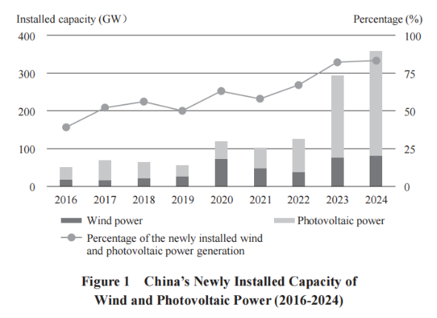

Developing hydropower as conditions permit. Hydropower is an important source of clean energy and provides a flexible supply of electricity in western China. Sound measures have been taken to coordinate hydropower development and eco-environmental conservation and integrate the development of wind, photovoltaic and hydropower. China is making active yet prudent efforts to construct critical hydropower projects on major rivers in the southwest, and to develop and build pumped-storage hydroelectric plants. By the end of August 2025, the regular installed hydropower capacity in China stood at around 380 GW, and that of pumped-storage hydropower stations at about 62.37 GW.

Pursuing robust, safe and orderly development of nuclear power. Nuclear power is an efficient and high-quality clean energy source. China is committed to developing nuclear power with the absolute requirement that safety is guaranteed, and to promoting the use of nuclear energy in clean heating, industrial heating, and seawater desalination. By the end of August 2025, China had 112 nuclear power units in operation, under construction, or approved for construction, with a combined installed capacity of 125 GW, ranking first globally. The strictest safety standards and regulations have made China a world leader in the safe operation of nuclear power.

Boosting the development of green hydrogen, biomass, geothermal and ocean energy. China is committed to the strategy of innovation-driven development. It actively promotes the whole-chain development of hydrogen in production, storage, transport and application, and is accelerating the cultivation of new products, new business forms, and new models. By the end of 2024, China led the world in the annual production capacity of green hydrogen energy – over 150,000 tonnes. China has diversified the exploration and utilization of biomass energy in accordance with local conditions. It is steadily advancing electricity generation from agricultural and forestry biomass, biogas, and urban domestic waste incineration. It is also promoting the use of biomass energy for clean heating, and the application of clean liquid fuels, such as bioethanol and biodiesel. By the end of August 2025, the installed capacity of biomass power generation had reached 46.88 GW, a 60 percent increase over 2020. In addition, China has built a series of centralized heating projects powered by geothermal energy. It is also reinforcing pilot demonstrations on harnessing ocean power such as tidal and wave energy. Progress has been made in the large-scale utilization of ocean energy.

2. Accelerating Clean and Efficient Utilization of Fossil Energy

China has continued to improve the clean and efficient utilization of fossil energy and rationally control its consumption. The proportion of fossil energy consumed dropped from 84.0 percent in 2020 to 80.2 percent in 2024.

Promoting clean and efficient use of coal, reducing its consumption, and replacing it with alternative energy resources. Based on its energy and resource endowment with coal as the mainstay, China is making coordinated progress in the stable supply of coal and low-carbon transition. It has intensified its efforts to develop eco-friendly and intelligent mines, and to reduce carbon emissions in the mining process. Measures have been taken to realize the energy-saving and low-carbon transformation of coal-fired power units and phase out outdated production capacity in the coal-fired power industry. Over the past decade, more than 100 GW of outdated production capacity has been phased out. China has also intensified its effort to reduce coal consumption and replace it with alternative energy resources in key industries and sectors. It is increasing the proportion of clean energy and the rate of electrification in the industrial sector, and replacing bulk coal with clean energy in a steady and orderly manner. The proportion of coal in China’s total energy consumption dropped from 56.7 percent in 2020 to 53.2 percent in 2024.

Advancing the green transition of oil and gas exploitation and utilization. China has fully implemented green production of oil and gas across the country. It is promoting the construction of green oil and gas fields and advancing the transformation and upgrading of crude oil refining and petrochemical industry, thereby realizing energy savings and reducing carbon emissions in the production process. It has accelerated replacement of traditional fuels with advanced biomass liquid fuels and sustainable aviation fuels. It has launched campaigns to upgrade the quality of refined oil products. In less than 10 years, the quality of refined oil has been upgraded by three levels, from Level III to Level VI, which took developed countries almost 30 years. As a result, vehicle exhaust emissions have been effectively reduced.

3. Greater Regulation Capacity of the Power System

With the large-scale development of new energy, China has substantially improved the reliability and resilience of its power system. It is now accelerating the construction of a new-type power system that is clean and low-carbon, secure and sufficient, economic and efficient, flexible and intelligent, and well-coordinated between supply and demand. It is integrating the development of power source-grid-load-storage, achieving large-scale development and application of renewable energy.

Improving the coordination and operation capacity of power sources. China takes full advantage of the flexibility of coal power, and is upgrading coal-fired power units to achieve flexible load regulation. More than 50 percent of coal-fired power units in China are now equipped with deep peak-shaving technologies. China is also building peak-shaving natural gas power stations, pumped-storage hydroelectric plants, and solar power plants adapted to local conditions, and increasing large-scale use of new power storage technologies. In addition, it is steadily achieving dispatch optimization through multi-energy complementarity on the power supply side and fully tapping the potential for peak-shaving. As a result, the safe operation and comprehensive regulation capabilities of the power system have greatly improved.

Strengthening complementarity and mutual assistance between power grids. China has implemented innovations to the structure, form, and operation mode of power grids, made them smarter, and adapted them to large-scale centralized new energy resources and distributed energy with vast volume and wide coverage. It has consolidated the physical foundations of a stable power system by improving the main framework of the power grid. An interconnected and mutually complementary power grid system covering six regions has been set up, substantially increasing the power allocation capacity across provinces and regions. In 2024, the amount of electricity transmitted across regions and provinces reached 924.7 TWh and 2,000 TWh respectively, up by 50 percent and 30 percent compared with 2020. The power distribution network has been upgraded to increase the capacity to accommodate new energy power. China is also actively developing smart microgrids, mainly for absorbing new energy to achieve compatibility and complementarity with the main power grids.

Promoting electricity load flexibility. China systematically integrates the resources of demand response, guides users to optimize their electricity storage and consumption mode, and releases a high proportion of electricity load flexibility for residents and general industry and commerce. Considering the high proportion of industrial electricity load, China encourages enterprises with high electricity loads to participate in the ancillary service market, increasing the demand response capacity and making the power system more flexible. The goal is to have the demand response capability account for 3 to 5 percent of the maximum electricity load by 2025, with that in eastern, central, and southern China reaching 5 percent.

Strengthening new types of energy storage. Energy storage is an important foundation for a new-type power system. China is integrating energy storage in all the stages of the power system. It is developing “new energy + energy storage”, and integrating power source-grid-load-storage, as well as multi-energy complementarity. With a focus on key grid nodes or remote areas, it is establishing rational new energy storage configurations. It also encourages electric vehicles and uninterruptible power supplies to participate in system peak shaving and frequency regulation, and promotes the diversified application of technologies, including lithium-ion batteries, flow batteries, compressed air energy storage, gravity energy storage, and flywheel energy storage. By the end of 2024, the installed capacity of new energy storage had reached 73.76 GW/168 GWh. This is 20 times the capacity in 2020, and represents more than 40 percent of the global total.

III. In-Depth Low-Carbon Development

in Key Areas

Industry, transport, construction, and daily life are key areas that generate carbon emissions and have a significant impact on achieving peak carbon and carbon neutrality. China has incorporated peak carbon and carbon neutrality into overall social and economic development and moved faster to establish green and low-carbon work models and lifestyles, in order to inject impetus into high-quality green development.

1. Accelerated Low-Carbon Industrial Development

China has coordinated innovation and integrated development in traditional and emerging industries, optimized and upgraded the industrial structure, and advanced the development of green and low-carbon industries. Industries have witnessed continuing green and low-carbon development.

In-depth green transition of traditional industries. China no longer approves energy-intensive projects with high emissions and outdated technology. It is continuing to update binding standards for environmental protection, energy efficiency, water efficiency, and carbon emission in key industries, and decommissioning outdated production capacity in accordance with relevant laws and regulations. China is shifting key industries towards green and low-carbon development and has continued to establish benchmarks in green manufacturing. It is rolling out the substitution of clean energy, supporting the establishment of zero-carbon emission industrial parks in areas where conditions permit, constructing eco-friendly industrial parks, and accelerating the substitution of low-carbon materials and the use of renewable resources. In 2024, China’s output of recycled non-ferrous metals reached 19.15 million tonnes – the largest in the world for the 15th consecutive year – and one in every four tonnes of electrolytic aluminum was produced using green electricity.

Opportunities for green and low-carbon industrial development constantly strengthened. China continues to create growth points for the green and low-carbon economy. The proportion of green and low-carbon industries has continued to grow in China’s economic aggregate. China has established the world’s largest and most complete industrial chains of clean energy, and the “New trio” of new energy vehicles, lithium-ion batteries, and photovoltaic products has become a new calling card for Chinese manufacturing. In 2024, new industries and new business forms and models, dubbed the “New trio” economy, accounted for over 18 percent of China’s GDP, and the added value of high-tech manufacturing represented 16.3 percent of the contribution of all industrial enterprises of designated size (enterprises with an annual revenue of RMB20 million and above), an increase of 1.2 percentage points compared with 2020.

Further coordinated progress of digital and green development. China is actively leveraging the positive role of digital development in increasing resource efficiency and environmental benefits, and expanding the application of artificial intelligence, big data, and cloud computing in power systems, industrial and agricultural production, transport, and building construction and operation. China is promoting the green and low-carbon development of data centers by coordinating the development of large-scale wind and photovoltaic power bases and national data hubs, and increasing the proportion of green electricity usage in data centers. A total of 246 data centers have been recognized as national green data centers, with green electricity accounting for more than half of the electricity used.

2. Faster Improvement in Clean and Low-Carbon Transport

China is boosting the development of low-carbon transport vehicles and equipment, progressively optimizing its transport structure, and accelerating its efforts to build a comprehensive modern transport system that is safe, convenient, efficient, green and economical.

Promoting low-carbon transport. China leads the world in the scale and speed of development of new energy vehicles. During the period from January to September 2025, the penetration rate of new energy passenger vehicles in the domestic market reached 52.2 percent, ranking top among major economies. China leads the world in the electrification of railways, with the electrification rate reaching 76.2 percent in 2024. China has promoted clean power in ships and aircraft. By 2024, fuel consumption per tonne/km of the civil aviation transport fleet had dropped by 20.5 percent compared to the 2005 baseline. China has moved further in the use of shore power for key anchored ships in key areas and on key routes. Over 90 percent of specialized berths in China’s major ports have access to shore power. China’s civil aviation airports lead the world in electrification. By the end of July 2025, electric vehicles accounted for 32 percent of all vehicles in China’s civil aviation airports.

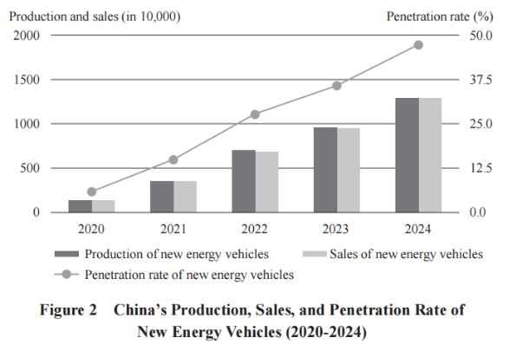

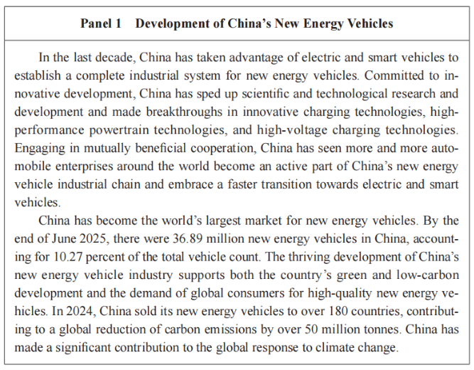

Progressive adjustment and upgrading of the transport structure. China has continued to improve its railway, highway and waterway networks and promoted the rational division of work and effective connection between various modes of transport. China supports a multimodal transportation system that uses a single bill of lading and eliminates the need for container changes, and is continuing to increase the proportion of railway and waterway freight transport. In 2024, the total turnover of rail freight increased by 17.5 percent, and water freight by 33.6 percent, compared with the end of the 13th Five-year Plan period (2016-2020), and the green transfer of coal and iron ore (by railway, waterway, enclosed belt conveyor, and new energy vehicle) at major coastal ports reached 88.4 percent.

Consistent upgrading of transport infrastructure for green development. China has upgraded its transport infrastructure for green development by promoting the construction of green highways, airways and waterways, strengthening the green and smart development of newly built stations, airports and ports, and improving new energy transport infrastructure. China has established the world’s largest charging network, leading in the number of charging facilities, compatibility with vehicle models, and area of coverage. By the end of August 2025, the total number of charging facilities for electric vehicles in China had reached nearly 17.35 million, a tenfold increase over a period of five years. China has emphasized the strategy of giving priority to public transport in urban areas and has accelerated the building of a green transport system. By the end of June 2025, China led the world in urban rail transit, with 330 lines in operation over a total track length of more than 11,000 km.

3. Higher-Quality Green and Low-Carbon Development in

Urban and Rural Areas

China has sped up the transition of development models in urban and rural areas and achieved a consistent improvement in quality in both green and low-carbon development and the people’s living environment.

Accelerated transition to low-carbon development in urban and rural planning. China capitalizes on and promotes the guiding role of green and low-carbon development throughout planning, construction and administration. It is steering the ongoing urban renewal drive to include the restoration of the urban ecosystem. China promotes green construction, the development of prefabricated buildings, and the application of green building materials. In 2024, the floor space of new prefabricated building projects under construction reached 672 million sq m, accounting for over 30 percent of all new buildings. By the end of June 2025, the number of products with a green building materials certificate exceeded 10,000. Efforts have been made to strengthen cities’ climate resilience, improve city ecosystems, and reserve sufficient river and lake eco-spaces and spaces for flood control and drainage. China has carried out demonstration projects to build 90 “sponge cities” and 39 pilot climate-adaptive cities. As of the end of 2024, the green coverage of built-up urban areas was 43.49 percent, and the per capita area of park greenery in urban areas was 15.91 sq m.

Substantive increase in energy efficiency of buildings. China has continued to raise standards and requirements for the energy efficiency of buildings, develop green buildings, and advance the energy-saving retrofit of existing buildings. In 2024, the floor space of China’s new green buildings accounted for almost 98 percent of all newly constructed buildings in urban areas. During the 14th Five-year Plan period (2021-2025), existing urban buildings underwent energy-saving retrofit, and the energy efficiency of public buildings increased by 20 percent after the retrofit. By the end of 2024, the floor space of energy-saving buildings accounted for more than 66 percent of all existing urban buildings.

Further use of clean and low-carbon energy in buildings. In order to reduce carbon emissions in the construction sector, China continues to increase the proportion of electricity in buildings’ energy consumption, promote the integrated application of photovoltaic power in buildings based on local conditions, and advance the use of heat pumps, biomass, and geothermal and solar energy for clean heating. In 2024, electricity consumption accounted for over 55 percent of China’s total building energy consumption. China has advanced clean energy heating in northern regions, with more than 40 million rural households retrofitted for clean heating systems. By the end of 2024, the proportion of clean energy heating in northern China had reached 83 percent, nearly 20 percentage points higher than in 2020.

4. Green and Low-Carbon Lifestyles Gaining Popularity

China has carried out an in-depth nationwide green and low-carbon campaign. Simple, moderate, green, low-carbon and healthy lifestyles have become a conscious choice for more and more people.

Moving faster to create green and low-carbon lifestyles. China advocates green and low-carbon lifestyles, guiding and encouraging the wide adoption of the Code of Conduct for Environmental Protection to promote green living. The share of green and low-carbon transport and travel continues to increase. An average of 200 million people now travel by public transport every day, with about 25 million using shared bikes. China has implemented full household waste sorting. By the end of 2024, 98.5 percent of residential compounds in cities at prefectural level and above had waste sorting facilities. China is promoting and exploring the carbon inclusion mechanism, with 27 provincial-level administrative units having launched policies related to green travel, power saving, recycling of used items, and waste sorting.

Expanded green and low-carbon consumption. China continues to increase the supply and upgrade the quality of green and low-carbon products, and incentivizes consumer goods trade-in. The country takes full advantage of green and low-carbon consumption both in driving economic growth and in reducing carbon emissions. It encourages the use of green and low-carbon products and curbs extravagance and excessive consumption, implementing the Clear Your Plate campaign to prevent food waste, and guiding the public to conserve water and electricity and reduce the use of disposable products.

IV. Effective Implementation of Major

Pathways to Carbon Emission Reduction

Energy conservation is key to reducing carbon emissions at source; the circular economy plays a crucial role in facilitating their reduction; and improving the carbon sink capacity of ecosystems is a vital path for emission reduction and carbon sequestration. China has yielded positive outcomes in its actions for saving energy, reducing carbon dioxide emissions, and improving efficiency; for facilitating further emission reductions through the circular economy; and for consolidating and improving carbon sink capacity.

1. Advancing Energy Saving, Carbon Reduction, and Efficiency Improvement Actions

China is committed to prioritizing energy conservation by transforming its energy consumption patterns to build an energy-saving society, as evidenced by a total of 11.6 percent decrease in energy consumption per unit of GDP in the first four years of the 14th Five-year Plan period after deducting energy used as raw materials and non-fossil energy consumption.

Significant improvement in energy conservation management. China continues to improve its laws, regulations, and standards on energy saving as it works towards forming a mature and efficient management system. It has established and improved the framework of energy-saving checks on fixed-asset investment projects. Since 2020, it has conducted supervision on industrial energy conservation at over 20,000 enterprises and performed diagnosis on industrial energy conservation and carbon reduction at over 12,000 enterprises and industrial parks. Clear requirements have been set for energy conservation management of key industries and enterprises, and meticulous and targeted energy-saving management of major energy consumers has been strengthened. Additionally, the country has applied market-oriented mechanisms such as energy performance contracting to motivate businesses. Currently, the total turnover of the energy conservation service industry has exceeded RMB500 billion, with new investment in energy performance contracting surpassing RMB170 billion in 2024.

Full implementation of key projects for saving energy and reducing carbon emissions. China is implementing energy-saving and carbon-reducing transformations in key industries to upgrade energy consumption management and unlock the potential for systematically conserving energy and reducing carbon emissions. The implementation of energy conservation and carbon reduction projects in industrial parks has enabled upgrades and cascade utilization of the energy system. Currently there are 491 national-level green industrial parks in China; their energy consumption per unit of industrial added value has dropped to two-thirds of China’s average level.

Breakthroughs in energy saving and efficiency improvement of key equipment. China is scaling up the deployment and application of advanced and high-efficiency energy-saving equipment. Through large-scale equipment renewal, over 20 million units (sets) of equipment in key sectors were upgraded in 2024, saving energy equivalent to 25 million tonnes of standard coal. Energy efficiency standards have been comprehensively upgraded for products with a focus on electric motors, industrial fans, pumps, compressors, transformers, heat exchangers, boilers, among others. By the end of 2024, the energy efficiency labeling system had covered all key energy-using products and equipment across 44 categories in five major energy-consuming sectors.

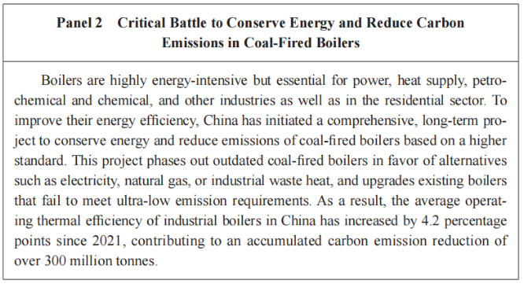

2. Significantly Reducing Carbon Emissions Through the Circular Economy

China continues to develop its circular economy to make more efficient use of resources, coordinating reductions in both resource consumption and carbon emissions.

Optimization of waste recycling management system. China has introduced targeted policies and measures on the management of waste from various sources and continued to develop its waste recycling system to realize precise management and effective recycling. In the industrial sector, measures have been taken to better oversee the production and disposal of general industrial solid waste, and further progress has been made in the category-specific collection and storage of industrial waste. In the agricultural sector, a mechanism to collect and dispose of agricultural waste such as livestock and poultry waste and crop straw has been established and streamlined, and the recycling of used agricultural items has seen significant improvement. In people’s daily life, a three-tier recycling network comprising collection points, stations, and centers has been developed to standardize the recycling of waste and used items. By the end of 2024, there were approximately 150,000 collection points and about 1,800 large-scale sorting centers of various types nationwide.

Steady improvement in waste utilization. China has applied tailored policies for different forms of waste to facilitate the standardized, large-scale and clean use of renewable resources. To date, some 100 recycling centers have been built across the country for the comprehensive utilization of bulk solid waste. In 2024, comprehensive utilization rate of the seven types of bulk solid waste, including coal gangue, coal ash, and mine tailings, reached 59 percent, an increase of 3 percentage points compared with 2020. The processing of renewable resources and the promotion and application of their products continue to be encouraged and strengthened throughout the country. In 2024, more than 400 million tonnes of major renewable resources were reused, including waste iron and steel, non-ferrous metals, paper, rubber, and glass. A total of 8.46 million scrap vehicles and 630,000 tonnes of waste household appliances were recycled in a standardized manner, representing year-on-year increases of 64 percent and 20 percent, respectively. China also provides strong support for its remanufacturing industry, which achieved an output value exceeding RMB200 billion in 2024 alone.

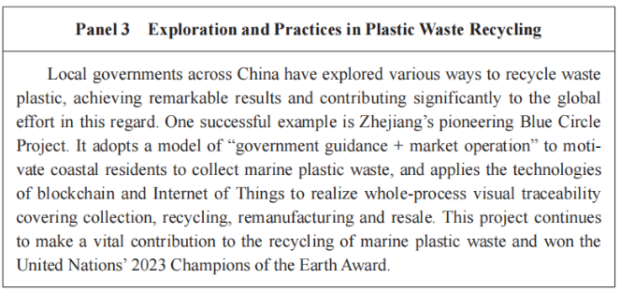

3. Improving Natural Ecosystems’ Carbon Sink Capacity

By staying committed to systems thinking, China ensures integrated conservation and management of mountains, waters, forests, farmlands, grasslands, and deserts, which helps to boost the carbon sink capacity of ecosystems. It is the first country to realize zero net land degradation, and its desertified and sandified areas are both shrinking, contributing to approximately one-fourth of the world’s newly added green areas over the past two decades.

Optimized pattern of carbon sequestration through ecosystems. China takes rigorous measures to protect the space of natural ecosystems and reduce the occupation of these areas by human activities. It has established a nationwide unified territorial space planning system that is science-based, efficient, and built upon clearly defined powers and responsibilities. This system draws three red lines for arable land and permanent basic cropland, eco-environmental protection, and boundaries for urban development, and setting protection lines for all types of sea areas. The protected areas system includes mainly national parks, supported by nature reserves and supplemented by natural parks. As part of China’s ecosystem-protection efforts, the first five national parks have been built, along with approximately 10,000 protected areas of various levels and types, covering some 18 percent of the country’s land area. These actions have enhanced the stability and service functions of ecosystems.

Steady increase in the carbon sink capacity of ecosystems facilitated by human interventions. A number of major projects for protecting and restoring key ecosystems have been launched across China, including greening programs to increase the country’s total volume of forest and grassland and leverage the critical function of forest carbon sinks. Today, China has achieved the highest growth in forest coverage in the world, and boasts the largest area of man-made forests. In 2024, forests covered 25.09 percent of China’s territory, with a forest stock of over 20.9 billion cu m, while grassland vegetation coverage reached 50.52 percent. China’s forests and grasslands now absorb and store over 1.2 billion tonnes of carbon dioxide equivalent annually. The country is also focusing on improving aquatic environments, water resources, and aquatic ecosystems by strengthening comprehensive ecological governance of rivers, lakes and oceans. By the end of 2024, its wetland area totaled over 53.3 million hectares, ranking first in Asia and fourth globally.

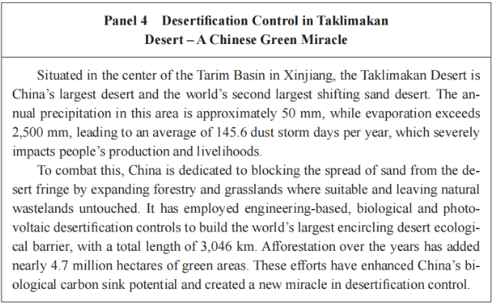

Steady progress of carbon reduction and sequestration in agriculture. China pursues green, low-carbon and circular agriculture. In 2024, the comprehensive utilization rates of crop straw and livestock and poultry waste were around 88 percent and 80 percent, respectively. It supports the development of low-carbon agricultural models, including agrivoltaic farming and “photovoltaics + facility agriculture”, and promotes efficient fertilization techniques and the replacement of chemical fertilizers with organic ones, aiming to control greenhouse gas emissions from crop production at a reasonable level. The country has also advanced energy conservation and carbon reduction in agricultural machinery through tailored actions to develop compound, efficient, and new energy-powered equipment while phasing out outdated equipment with high energy consumption, high emissions, and low safety performance. The conservation project of chernozem soil remains ongoing, efforts to restore degraded arable land have been intensified, protection-oriented farming continues to be practiced, the carbon sink capacity of farmland soil has been improved, and planting adaptability has been enhanced nationwide. Additionally, ecological fisheries are being developed in large water bodies to cultivate the industry’s carbon sink potential.

V. Continuous Consolidation of

Support and Safeguard Systems

China is continuing to strengthen its foundational capabilities in carbon emissions statistics, accounting, measurement standards, and other related aspects, while boosting scientific and technological innovation and improving its economic support policies and market-based mechanisms to systematically bolster its carbon reduction efforts.

1. Continuously Raising Foundational Capabilities

Establishing a unified and standardized statistics and accounting system for carbon emissions. China has improved carbon emissions statistics and accounting systems at both the national and provincial level by adopting uniform data standards and accounting methods. By introducing greenhouse gas emissions accounting methods and relevant national standards for enterprises in key sectors such as power, steel, and non-ferrous metals, it has refined the carbon emissions accounting mechanisms for these sectors. It has also improved the compilation mechanism for the national greenhouse gas inventory by establishing processes for regular management and updating. Additionally, it has launched a national greenhouse gas emissions factors database, with the first edition containing nearly 300 emissions factors.

Refining the standards and measurements for peak carbon and carbon neutrality. China has established a robust standards framework for its peak carbon and carbon neutrality goals, issuing 110 national standards in total, covering corporate carbon accounting, energy efficiency and consumption, carbon reduction through the circular economy, green products, and carbon reduction technologies. The country is also strengthening its carbon metrology capacity, having approved the establishment of 11 national metrological benchmarks, 71 types of metrological standard devices, and 134 types of standard materials related to carbon emissions. Progress has been made in establishing national carbon measurement centers.

Improving the management of carbon footprints. China has consolidated the foundation of carbon footprint accounting standards by releasing the standard Greenhouse Gases – Carbon Footprint of Products – Requirements and Guidelines for Quantification, which provides general rules for carbon footprint accounting of products, as well as 13 national standards for product carbon footprints, covering key products such as electrolytic aluminum, livestock products, plastic products, and internal combustion engines. Two batches of recommended group standards for carbon footprint accounting rules for industrial products have also been released, involving a total of 38 group standards that cover key products such as iron and steel, non-ferrous metals, and cement. The 2023 and 2024 electricity carbon footprint factors have been issued. Additionally, the country has improved the certification system for carbon labeling of products and carried out pilot work on product carbon footprints, involving 10 categories of key products and 26 certifying institutions. It has also organized special supervision and inspection of carbon emissions verification, inspection and testing institutions to promote the supporting capabilities of inspection and testing technologies.

2. Adopting Effective Support Policies

Improving economic policies that support green and low-carbon development. China has introduced and improved financial, tax and price policies that support green and low-carbon development. It has adopted compulsory and prioritized government procurement of energy-efficient and environmentally friendly products, with government procurement accounting for about 85 percent of the total procurement of such products. It has optimized green electricity pricing policies and green investment policies, improved the green finance standard system, and implemented structural monetary policy tools such as those supporting carbon reduction. It has improved the policy framework for climate investment and financing, launched 23 local pilot programs for climate investment and financing, and guided local governments to build climate investment and financing project pools. By the end of 2024, China’s balance of green loans in local and foreign currencies stood at RMB36.6 trillion, with nearly 70 percent of the loans being directed towards projects with carbon emissions reduction effects. In the same year, the premium income of green insurance businesses reached RMB333.15 billion, while the issuance of green bonds reached RMB681.43 billion, 2.5 times that of 2020.

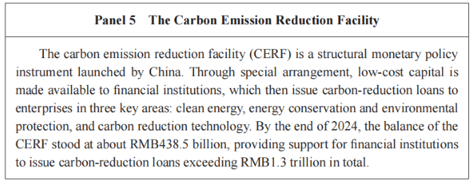

Implementing large-scale equipment renewal and consumer goods trade-in. China has rolled out large-scale equipment renewal and consumer goods trade-in programs to promote the production and application of advanced equipment, increase the proportion of advanced production capacity, and encourage wider use of higher-quality consumer durables by residents. This is not only an economic policy, rather, it is a long-term climate policy aimed to promote the green transformation. From January to August 2025, new energy vehicles accounted for over 60 percent of car trade-in sales, and appliances of Level 1 energy efficiency – the highest level of efficiency – made up 92 percent of home appliances trade-in sales; more than 9,000 community-based smart recycling facilities were added nationwide. The renewal and trade-in policies are expected to result in energy saving equivalent to over 69 million tonnes of standard coal and reduction of carbon emissions of over 170 million tonnes between 2024 and 2025.

3. Boosting Scientific and Technological Innovation as an Enabling Factor

Strengthening innovation in cutting-edge and disruptive low-carbon technologies. China attaches great importance to basic research in key technologies for peak carbon and carbon neutrality goals. This has allowed the country to consistently achieve breakthroughs in key areas such as renewable energy, energy storage, and smart power grids. In 2024, China’s international patent applications for green and low-carbon technologies under the Patent Cooperation Treaty reached 6,356, which was 2.3 times of the number in 2020, ranking first in the world for the fourth consecutive year.

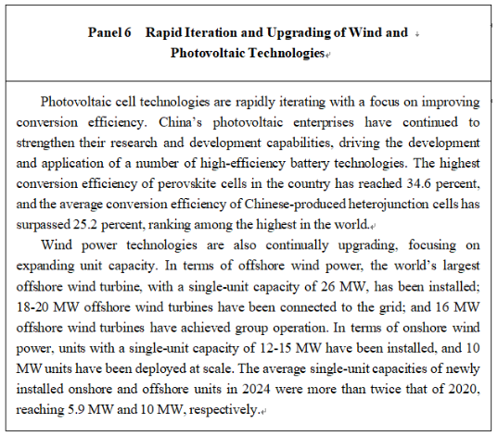

Promoting the application of advanced and applicable green, low-carbon technologies. China continues to implement demonstration projects of advanced green and low-carbon technologies. It has released 148 advanced green and low-carbon demonstration projects in two batches and 227 national key low-carbon technologies in five batches, and has strengthened the transformation and industrialization of mature, advanced and applicable low-carbon technologies. It has introduced inventories of energy-efficient and carbon-reducing technologies and equipment and major environmental protection technologies and equipment to guide enterprises to actively adopt energy-efficient, carbon-reduction and pollution-reduction technologies.

4. Gradually Improving the Market-Oriented Mechanism

Improving the institutional framework of China’s carbon emissions trading market. In July 2021, China officially launched its national carbon emissions trading market, which includes industries such as electricity, iron and steel, cement, and aluminum metallurgy, covering more than 60 percent of the country’s carbon emissions. As of the end of September 2025, the cumulative quota trading volume in this market had reached some 728 million tonnes, with a cumulative trading value of about RMB49.83 billion.

Making new progress in the construction of its voluntary greenhouse gas emissions reduction trading market. In January 2024, China launched its national voluntary greenhouse gas emissions reduction trading market (China Certified Emission Reduction market), and introduced methodologies for six types of projects, including carbon sequestration through afforestation. As of the end of October 2025, a total of 31 projects had been registered, achieving an emissions reduction of 15.04 million tonnes, while the cumulative trading volume had reached about 3.23 million tonnes, with a turnover of about RMB270 million.

Enhancing the vitality of the green-certificate and green electricity market. Green certificates now cover the entirety of China’s renewable energy power generation sector. As of the end of August 2025, China had issued a total of some 6.92 billion green certificates, about 4.66 billion of which were tradable. The country officially launched its green electricity trading market in September 2021, and by the end of August 2025, power trading centers in China completed green electricity trading of 205 TWh, a year-on-year increase of 43.3 percent.

VI. Strong Impetus to Global

Climate Governance

Climate change is a common challenge for all humanity, and one that demands widespread participation and collective action to address. Through its commitment to multilateralism and international cooperation, China is now charting a new course for global climate governance.

1. Engaging in and Leading Global Climate Governance

China remains a leader in steering the course of global climate governance. It has actively pushed for the signing, effecting and implementation of the Paris Agreement, and has championed the goals, principles and frameworks set in the United Nations Framework Convention on Climate Change (hereinafter referred to as the Convention) and the Paris Agreement under it. It is committed to the principle of equity and common but differentiated responsibilities and respective capabilities, in a bid to build a fair and rational global climate governance system for win-win results through cooperation.

Participating in the formulation of international rules. China has actively participated in the global climate negotiations agenda in a constructive manner and made historic contributions to the conclusion, signing, effecting and implementation of the Paris Agreement. It has also engaged in negotiations and substantive work via a range of multilateral channels, including the Group of 20, the Intergovernmental Panel on Climate Change, the International Maritime Organization, and the International Civil Aviation Organization outside the Convention, to build broad consensus.

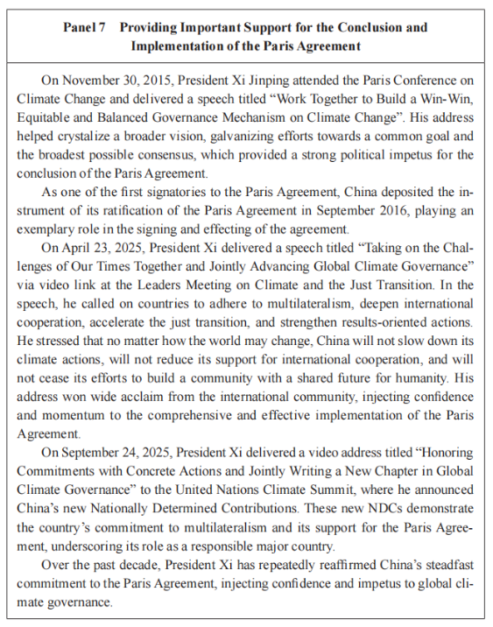

Implementing the Convention and the Paris Agreement. In line with the requirements of the Paris Agreement, China has demonstrated the highest possible ambition in its national climate action plan (also known as NDCs), taken the most substantial measures for action, and advanced its goals resolutely. China has actively fulfilled reporting obligations, compiling and submitting National Greenhouse Gas Inventory, National Communication, Biennial Update Report, and Biennial Transparency Report on a timely basis as mandated, demonstrating high-standard and consistent compliance.

2. Promoting Green Development under the Belt and Road Initiative

With the cooperation in green infrastructure, energy and transport between China and other Belt and Road partner countries continuing to expand, “green” has become the defining feature of high-quality Belt and Road cooperation.

Pragmatic cooperation in green energy. China has built energy cooperation platforms with six regional organizations, namely the Association of Southeast Asian Nations, the League of Arab States, the African Union, Central and Eastern Europe, the Shanghai Cooperation Organization, and the Asia-Pacific Economic Cooperation; established energy partnerships with 34 countries along the Belt and Road; and worked with more than 100 countries and regions on green energy projects. Over the years, China has developed numerous clean power projects in Belt and Road partner countries, contributing to their green energy transition and high-quality development.

Institutional connectivity of standards and norms for green development. China has continued to align its green and low-carbon industrial and technical standards with those of Belt and Road partner countries by promoting mutual recognition of standards for green electricity, green electricity certificates, and carbon footprints. It has improved institutional connectivity with those countries in terms of green projects screening, and environmental and climate information disclosure. The Green Investment Principles for the Belt and Road Initiative have been launched to create an enabling investment environment.

Physical connectivity of green infrastructure. In conducting cooperation with Belt and Road partner countries in the infrastructure of power and transport, China has acted on the principles of low carbon emissions and eco-friendliness throughout the planning, construction and operation processes. This is showcased by projects like the China-Laos Railway, an electrified railway reducing carbon emissions by more than 70 percent compared with traditional diesel locomotives, and the Addis Ababa Ring Road in Ethiopia, which incorporates innovative green solutions such as citywide new energy infrastructure and rainwater recycling systems to significantly reduce energy and resource consumption.

3. Fruitful International Cooperation on Green and Low-Carbon Development

Committed to the principle of common but differentiated responsibilities, China has advanced high-standard and high-quality international cooperation on green and low-carbon development, offering financial, technological and capacity-building support to the best of its ability to countries of the Global South.

Green products trade. China consistently provides quality, efficient and low-carbon energy solutions to the world, particularly to developing countries. Its photovoltaic and wind power equipment and new energy vehicles have been exported to over 200 countries and regions, supplying 70 percent of the world’s wind power equipment and 80 percent of photovoltaic panels, which have helped to reduce the global cost of wind and photovoltaic power generation by more than 60 percent and 80 percent, respectively. The wind power equipment and photovoltaic products China exported during the 14th Five-year Plan period have reduced carbon emissions of around 4.1 billion tonnes in other countries.

Green technology cooperation. China has expanded cooperation on green and low-carbon innovation with an open and inclusive approach, initiated international science and technology innovation cooperation plans on carbon neutrality, and built regional international low-carbon organizations and international cooperation platforms for green and low-carbon technology. By the end of October 2025, China had established science and technology cooperation with over 160 countries and regions, signed 120 intergovernmental agreements on science and technology cooperation, and joined over 200 international organizations and multilateral mechanisms in this field.

Deeper South-South cooperation in coping with climate change. China supports other developing countries in building their capacity to respond to climate change through a holistic approach that integrates green vision, green technology, and clean energy. Since 2016, it has provided and mobilized RMB177 billion worth of project funds in this regard. By the end of October 2025, China has signed 55 memoranda of understanding on South-South cooperation to address climate change with 43 developing countries and conducted over 300 sessions of capacity-building programs.

Conclusion

Humanity as an indivisible community shares a common planet and a common destiny. In the face of climate change, concrete actions, unbreakable solidarity, and forward-looking cooperation are now more necessary than ever.

China is a determined participant in and a major contributor to global climate governance. Over the past five years, the country, guided by the goals of peak carbon and carbon neutrality, has coordinated efforts to cut carbon emissions, reduce pollution, expand green development, and pursue economic growth. These steps have helped to accelerate greener economic and social development in all respects. The country’s commitment to a sound development path of increased economic output, higher living standards, and healthy ecosystems has opened up broad prospects for the sustained development of the Chinese nation and injected strong momentum into global climate change action.

Looking forward, China stands ready to work with the international community to advance eco-environmental conservation, promote green development, address global climate challenges, protect the green Earth, and secure a cleaner and more beautiful world.

来源：新华网11月8日
https://english.news.cn/20251108/c47cb3e85468475f84182f8a7c791ecb/c.html

